**WEEK – 7**

**React**

**9. Create a React Application named “cricketapp” with the following components**

**ListOfPlayers.js**

import React from 'react';

const players = [

  { name: "Virat", score: 85 },

  { name: "Rohit", score: 65 },

  { name: "Gill", score: 92 },

  { name: "Rahul", score: 45 },

  { name: "Pant", score: 73 },

  { name: "Hardik", score: 51 },

  { name: "Jadeja", score: 88 },

  { name: "Ashwin", score: 60 },

  { name: "Bumrah", score: 76 },

  { name: "Shami", score: 82 },

  { name: "Kuldeep", score: 55 },

];

const ListOfPlayers = () => {

  const highScorers = players.map((p, i) => (

    <li key={i}>{p.name}: {p.score}</li>

  ));

  const lowScorers = players.filter(p => p.score < 70).map((p, i) => (

    <li key={i}>{p.name}: {p.score}</li>

  ));

  return (

    <div>

      <h2>All Players</h2>

      <ul>{highScorers}</ul>

      <h3>Players with score below 70</h3>

      <ul>{lowScorers}</ul>

    </div>

  );

};

export default ListOfPlayers;

**IndianPlayers.js**

import React from 'react';

const IndianPlayers = () => {

  const T20players = ["Virat", "Rohit", "Gill", "Pant"];

  const RanjiPlayers = ["Jadeja", "Pujara", "Rahane"];

  const allPlayers = [...T20players, ...RanjiPlayers];

  const oddPlayers = allPlayers.filter((_, idx) => idx % 2 === 1);

  const evenPlayers = allPlayers.filter((_, idx) => idx % 2 === 0);

  return (

    <div>

      <h2>Even Team Players</h2>

      <ul>{evenPlayers.map((p, i) => <li key={i}>{p}</li>)}</ul>

      <h2>Odd Team Players</h2>

      <ul>{oddPlayers.map((p, i) => <li key={i}>{p}</li>)}</ul>

    </div>  );};export default IndianPlayers;

App.js

import React from 'react';

import ListOfPlayers from './components/ListOfPlayers';

import IndianPlayers from './components/IndianPlayers';

function App() {

  const flag = false;

  return (

    <div className="App">

      <h1>🏏 Cricket App</h1>

      {flag ? <ListOfPlayers /> : <IndianPlayers />}

    </div>

  );

}export default App;

**Output:**

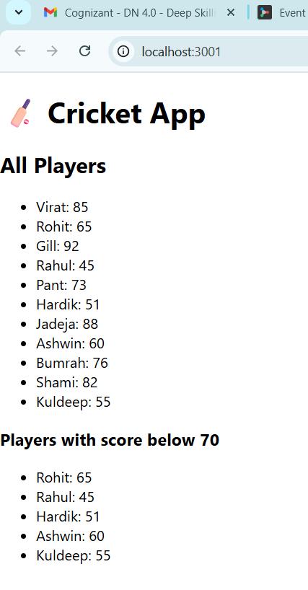 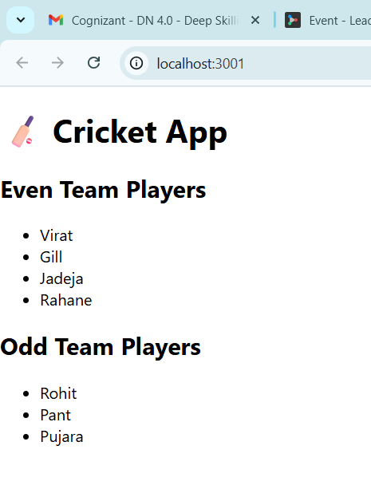

**10.** **Create a React Application named “officespacerentalapp” which uses React JSX to create elements, attributes and renders DOM to display the page**

**App.js**

import React from 'react';

function App() {

  const offices = [

    {

      name: "Prestige Tech Park",

      rent: 55000,

      address: "Bangalore",

      image: "http://images.unsplash.com/photo-1570126618953-d437176e8c79?ixlib=rb-1.2.1&q=80&fm=jpg&crop=entropy&cs=tinysrgb&w=1080&fit=max&ixid=eyJhcHBfaWQiOjEyMDd9"

    },

    {

      name: "MindSpace",

      rent: 65000,

      address: "Hyderabad",

      image: "https://cdn.pixabay.com/photo/2023/03/07/12/39/ai-generated-7835664_960_720.jpg"

    }

  ];

  return (

    <div style={{ textAlign: "center", fontFamily: "Arial" }}>

      <h1>🏢 Office Space Rental App</h1>

      {offices.map((office, index) => (

        <div key={index} style={{

          border: "1px solid #ccc",

          borderRadius: "10px",

          padding: "15px",

          margin: "15px auto",

          width: "300px",

          boxShadow: "2px 2px 10px rgba(0,0,0,0.1)"

        }}>

          <img src={office.image} alt={office.name} width="200" height="120" />

          <h2>{office.name}</h2>

          <p><strong>Address:</strong> {office.address}</p>

          <p>

            <strong>Rent:</strong>{" "}

            <span style={{

              color: office.rent > 60000 ? "green" : "red",

              fontWeight: "bold"

            }}>

              ₹{office.rent}

            </span>

          </p>

        </div>

      ))}

    </div>

  );

}

export default App;

**Output:**

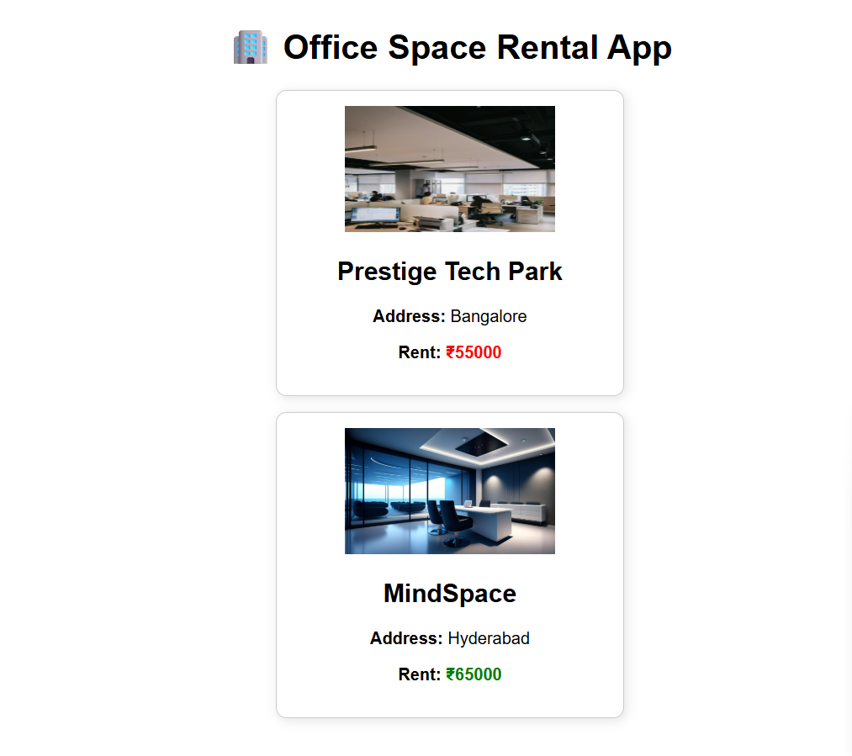

**11. Create a React Application “eventexamplesapp” to handle various events of the form elements in HTML**

**App.js**

import React, { Component } from 'react';

import CurrencyConvertor from './CurrencyConvertor';

class App extends Component {

  constructor() {

    super();

    this.state = {

      count: 0,

    };

  }

  increment = () => {

    this.setState(prevState => ({ count: prevState.count + 1 }));

  };

  sayHello = () => {

    console.log("Hello! This is a static message.");

  };

  increaseHandler = () => {

    this.increment();

    this.sayHello();

  };

  decrement = () => {

    this.setState(prevState => ({ count: prevState.count - 1 }));

  };

  sayWelcome = (msg) => {

    alert(`Message: ${msg}`);

  };

  handleSyntheticEvent = (e) => {

    e.preventDefault();

    alert("I was clicked");

  };

  render() {

    return (

      <div style={{ textAlign: "center", marginTop: "20px" }}>

        <h1>React Event Handling Example</h1>

        <h2>Counter: {this.state.count}</h2>

        <button onClick={this.increaseHandler}>Increment</button>

        <button onClick={this.decrement}>Decrement</button>

        <br /><br />

        <button onClick={() => this.sayWelcome("Welcome to React Events")}>

          Say Welcome

        </button>

        <br /><br />

        <button onClick={this.handleSyntheticEvent}>Synthetic Event Button</button>

        <br /><br />

        <CurrencyConvertor />

      </div>

    );

  }

}

export default App;

**CurrencyConvertor.js**

import React, { useState } from 'react';

const CurrencyConvertor = () => {

  const [rupees, setRupees] = useState('');

  const [euro, setEuro] = useState(null);

  const handleSubmit = (e) => {

    e.preventDefault();

    const converted = parseFloat(rupees) / 90;

    setEuro(converted.toFixed(2));

  };

  return (

    <div>

      <h2>💱 Currency Converter</h2>

      <form onSubmit={handleSubmit}>

        <input

          type="number"

          placeholder="Enter amount in ₹"

          value={rupees}

          onChange={(e) => setRupees(e.target.value)}

        />

        <button type="submit">Convert to Euro</button>

      </form>

      {euro && (

        <p>

          ₹{rupees} = €{euro}

        </p>

      )}    </div>

  );};export default CurrencyConvertor;

**Output:**

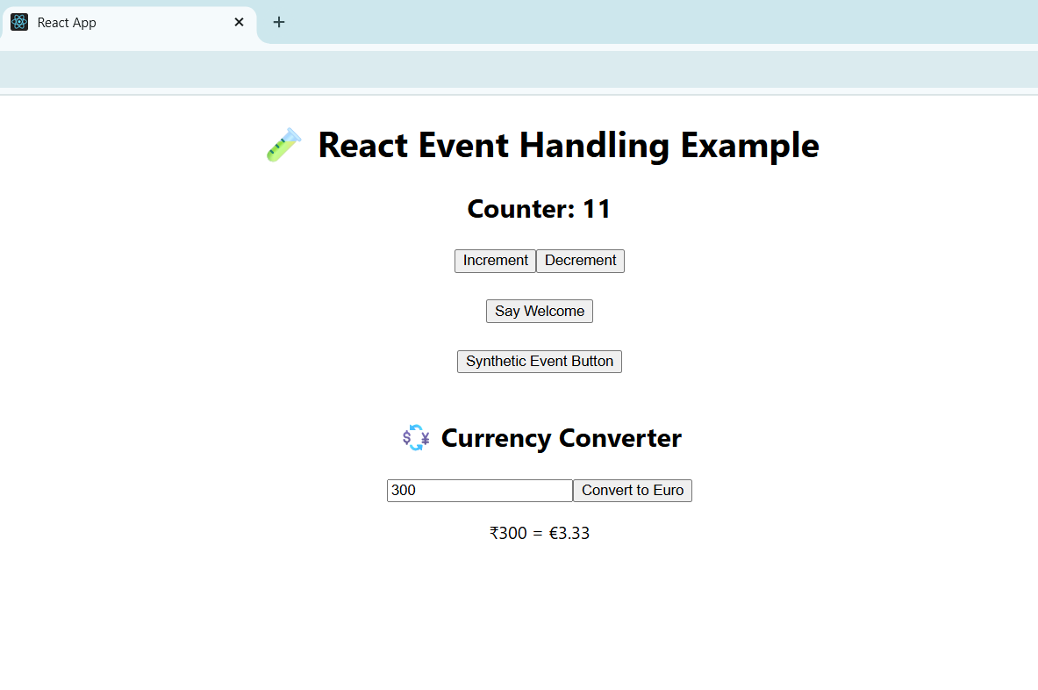

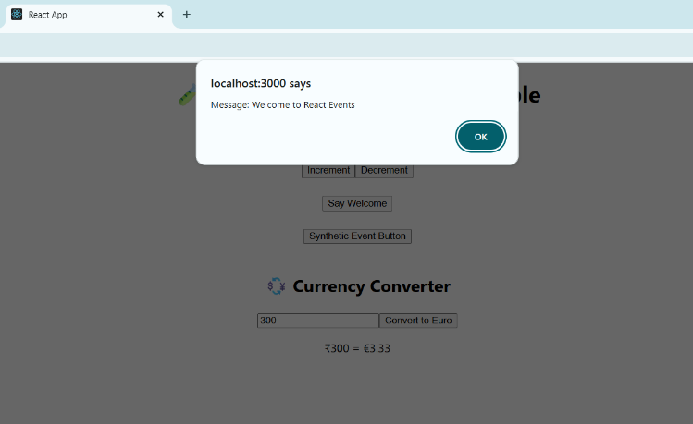

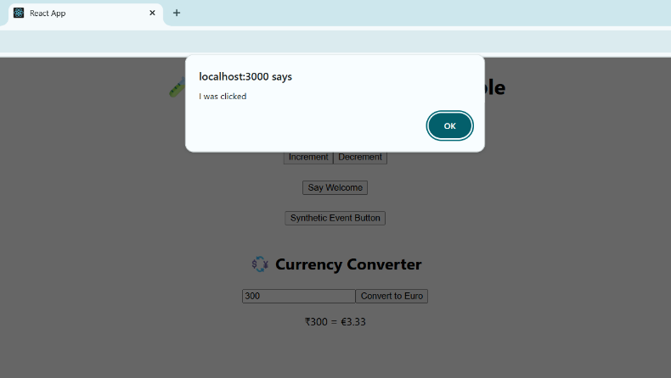

**12.** **Create a React Application named “ticketbookingapp” where the guest user can browse the page where the flight details are displayed whereas the logged in user only can book tickets**

**GuestPage.js**

import React from 'react';

const GuestPage = () => {

  return (

    <div>

      <h2>✈️ Welcome Guest</h2>

      <p>Here are the available flights:</p>

      <ul>

        <li>Indigo – Bangalore to Delhi</li>

        <li>Air India – Mumbai to Chennai</li>

        <li>SpiceJet – Hyderabad to Kolkata</li>

      </ul>

    </div>  );};export default GuestPage;

**UserPage.js**

import React from 'react';

const UserPage = () => {

  return (

    <div>

      <h2>Welcome Back!</h2>

      <p>You are logged in. Book your tickets here:</p>

      <button>Book Indigo Flight</button>

      <button>Book Air India Flight</button>

      <button>Book SpiceJet Flight</button>

    </div>  );};export default UserPage;

**Output:**



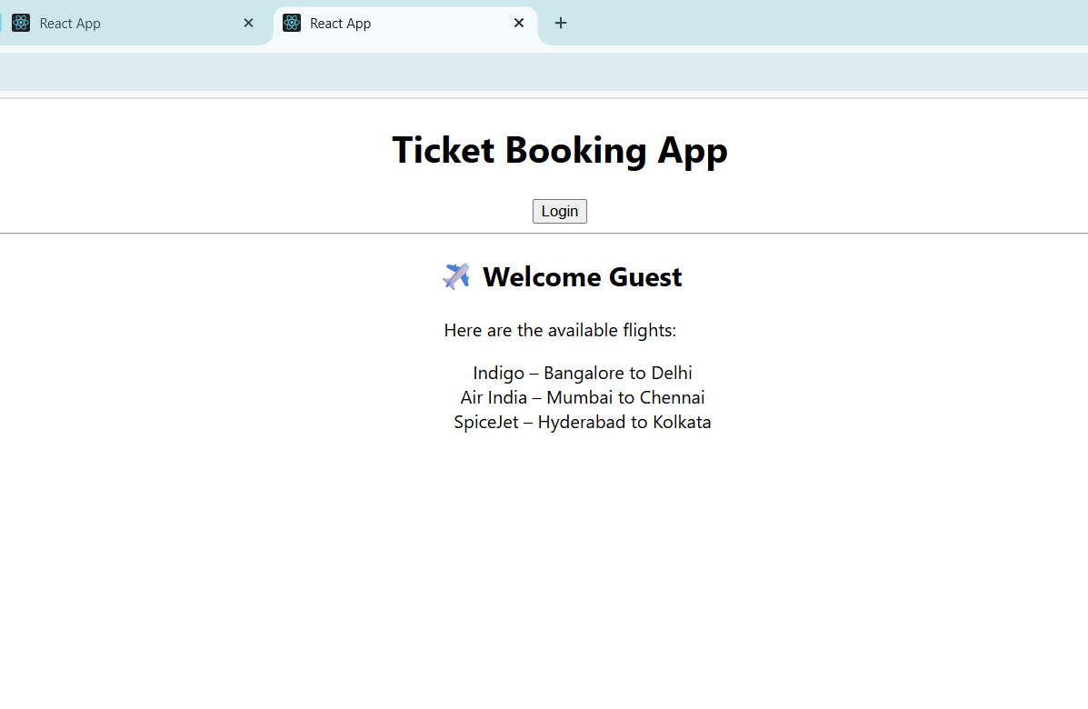

**13.** **Create a React App named “bloggerapp” in with 3 components**

**BlogDetails.js**

import React from 'react';

const BlogDetails = () => {

  return (

    <div>

      <h2>Blog Details</h2>

      <p><strong>React Learning</strong></p>

      <p><em>Stephen Biz</em></p>

      <p>Welcome to learning React!</p>

      <p><strong>Installation</strong></p>

      <p><em>Schwezdenier</em></p>

      <p>You can install React from npm.</p>

    </div>

  );

};export default BlogDetails;

**BookDetails.js**

import React from 'react';

const BookDetails = () => {

  return (

    <div>

      <h2>Book Details</h2>

      <p><strong>Master React</strong></p>

      <p>670</p>

      <p><strong>Deep Dive into Angular 11</strong></p>

      <p>800</p>

      <p><strong>Mongo Essentials</strong></p>

      <p>450</p>

    </div>

  );

};

export default BookDetails;

**CourseDetails.js**

import React from 'react';

const CourseDetails = () => {

  return (

    <div>

      <h2>Course Details</h2>

      <p><strong>Angular</strong></p>

      <p>4/5/2021</p>

      <p><strong>React</strong></p>

      <p>6/3/2021</p>

    </div>

  );

};

export default CourseDetails;

**App.js**  
import React from 'react';

import CourseDetails from './components/CourseDetails';

import BookDetails from './components/BookDetails';

import BlogDetails from './components/BlogDetails';

import './App.css';

function App() {

  return (

    <div className="app">

      <div className="section"><CourseDetails /></div>

      <div className="section"><BookDetails /></div>

      <div className="section"><BlogDetails /></div>

    </div>

  );

}

export default App;

**Output:**

